Geneos Monitoring
Run Book
Global Operations
This document describes the Geneos monitoring environment, and all associated procedures which have been created in order to provide support.

Document Id: | GENEOS270411
Document Version: | 3
Document Owner: | Global Operations
Last updated: | June 4, 2015 by Tony Hale
Classification: | Tullett Prebon - Internal Use Only

Whilst all reasonable care has been taken to ensure that the details are true and not misleading at the time of publication, no liability whatsoever is assumed by Tullett Prebon, or any subsidiary of Tullett Prebon, with respect to the accuracy or any use of the information provided herein.

This document contains confidential information and may not be modified or reproduced, in whole or in part, or transmitted in any form to any third party, without the written approval from Tullett Prebon.

Contents
1 Document Control 3
1.1 Document location 3
2 Support Summary Sheet 4
3 Geneos Monitoring 5
3.1 Overview of Geneos Monitoring 5
3.2 Reader pre-requisites 6
3.3 SYSTEM OPEN HOURS 6
3.4 SYSTEM CLOSE HOURS 7
4 Geneos Key Contacts 8
5 Logical Architecture 9
6 Geneos Production Environment 10
6.1 Architectural Components 10
6.2 Installed Third Party Software and Versions 11
7 Geneos Operational Support 12
7.1 Introduction 12
7.2 Support Tools 12
7.2.1 Desktop Firewall authentication 12
7.2.2 Geneos Active Console 13
7.3 Start of Day Activities 14
7.4 End of Day Activities 15
7.5 Automated Monitoring 15
7.6 Automatic Failover 15
7.7 Manual Failover 15
7.8 Failback 15
7.9 Backup 15
7.10 Restore 15
7.11 Archiving 15
7.12 Incident Management 16
8 Geneos Licence Updates 17
9 Geneos Primary Site Failure 18
10 Geneos SAN failure 19
11 Change Management 20

Document Control
  - Document location
Document location
http://tpwiki/display/MESI

Revision History
Note that version numbering should be 1,2,3, 4… and not 0.1, 0.2, 1.1 etc.
Version | Date | Changed by | Summary of Changes
1 | 2011-04-26 | MO ALI | Original creation of document
2 | 2011-05-04 | MO ALI | Added licence updating instructions
3 | 2011-05-11 | Tony Hale | Amended licence updating instructions
4 | 2013-09-30 | L Bertin | Modified license update for shared license daemon – Added license check page.

Approvals
This document requires the following approvals:
Name | Title
Alan Skamarak | TradeBlade US Operations Manager, Applications Dev
Warren Cranwell
Richard Durant

Document references
Name | Location

Support Summary Sheet

Support WIKI page | http://tpwiki/display/MESI/Home
1st Line Support | Mon – Fri, 7am to 7pm UK time, excluding bank holidays provided by Production Support department  Tel:  Email:  All other times, On Call Support provided by Production Support department  Tel:  Email:  Emergency contact number:
2nd Line Support | UK Business Hours only provided by Marker Development  Tel: +44 (0) 20 7200 7932  Email:  Emergency contact number:
3rd Line Support | UK Business Hours only except for emergencies:  Matt Dobson Tel: Email: mdobson@tullettprebon.com  Mo Ali Tel: 07877637306 Email:mali@tullettprebon.com  Colin Crist Tel: 07768877899 Email: ccrist@tullettprebon.com  Igor Vujosevic Tel: 07974198842 Email: ivujosevic@tullettprebon.com
Issue notification list | All application owners available here:  Support emails  tbglobalops@tullettprebon.com
In case of emergencies | - Send an email detailing the issue to the following email addresses:  tbglobalops@tullettprebon.com  - Contact the emergency contacts listed above
System Monitoring | Please follow the daily and on-screen checks detailed in this document

Geneos Monitoring

  - Overview of Geneos Monitoring

The Geneos monitoring tool is used to capture application and hardware metrics. The data generated can be automatically analysed and applied against pre-defined rules. These rules are used to trigger alerts - either on screen or sent as emails.

The monitoring tool can monitor application state (e.g., up time, memory use) and hardware and network resources (e.g., cpu, memory, hard disk, network availability).

The Geneos monitoring tool is currently used to monitor a number of live applications in Tullett Prebon:

1 | TP BUS | http://tpwiki/display/MESI/Monitoring
2 | TP FIX | http://tpwiki/display/TBFIXGW/Monitoring
3 | TP DELTADEAL | http://tpwiki/display/MBOX/Monitoring

The Geneos monitoring tool comprises the following components:

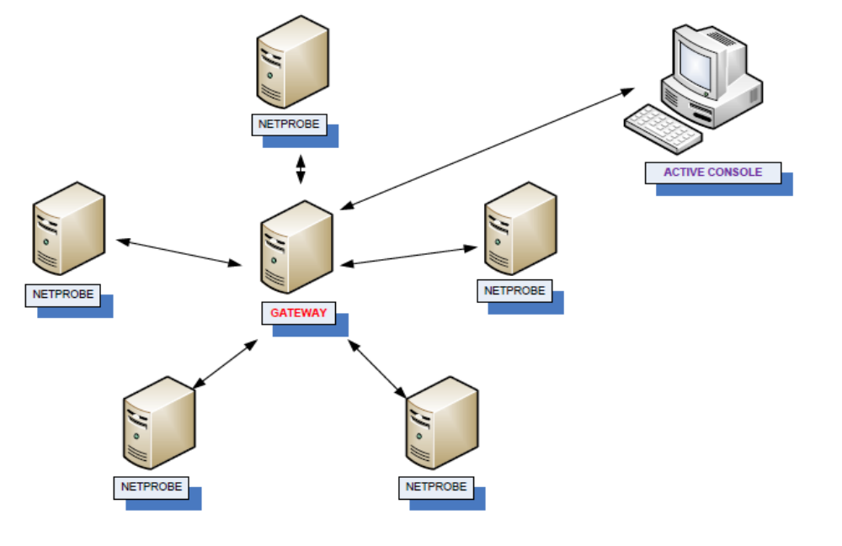
1
2
3

Key

1 | Geneos Netprobes | Netprobes are executables with small footprints installed on server machines / desktops (Windows or Linux). Netprobes require no configuration locally. Netprobes generate metrics regarding local applications and resources. This data is communicated to the Geneos Gateway.
2 | Geneos Gateway | The Geneos Gateway is configured with the location (hostname, port) of every Netprobe to be monitored.  The Geneos Gateway centrally receives all monitoring data from netprobes. The gateway is configured to apply rules against the data being processed – this will therefore generate alerts if rule thresholds are met (e.g., if memoryconsumption > 80%)
3 | Geneos Active Console | The Geneos Active Console is installed on user desktops. This desktop application can view and edit configurations that affect the amount and type of data retrieved from netprobes.  In addition, the active console can create dashboards which can graphically represent a system or environment. The graphical representation can bring together data and alerts from a number of netprobes into a single, easy to view, display.

  - Reader pre-requisites

Please make sure you read and understand the following topics before proceeding:

ITRS Documentation | http://asp.itrsgroup.com/help/secure/geneoshelp/GENEOS%20Help%20Index/gw2index.html  (Please register online)
Geneos WIKI | http://tpwiki/display/GOS/Home

  - SYSTEM OPEN HOURS

The system operates globally 24x7

  - SYSTEM CLOSE HOURS

There are no close hours. Any outage, maintenance or restart must be notified to TP Global Operations

Geneos Key Contacts

 |  | Business | Mobile | Home | Email
1ST LINE SUPPORT
Unix Administrators |  |  |  |  | unixadministrators@tullib.com
Declan Wyatt |  |  |  |  | dwyatt@tullettprebon.com
2ND LINE SUPPORT AND APPLICATION ONBOARDING
Mo Ali |  | 020 7200 7636 | 07877637306 | 07877637306 | mali@tullettprebon.com
Igor Vujosevic |  | 020 7200 7260 | 07974198842 | 07974198842 | ivujosevic@tullettprebon.com
3RD LINE SUPPORT
Matt Dobson |  | 020 7200 7932 |  |  | mdobson@tullettprebon.com
Colin Crist |  | 020 7200 7610 | 07768877899 | 07768877899 | ccrist@tullettprebon.com
Platform Owner
Richard Durant
Operations
Warren Cranwell | Operations London | 020 7200 7615 | 07507 558 900 | 07775 938 778 | wcranwell@tullettprebon.com
Adam Threadgold | Operations London |  |  |  | athreadgold@tullettprebon.com

Logical Architecture

As per section 3.1

Geneos Production Environment

The following diagram describes the Geneos Production Environment:
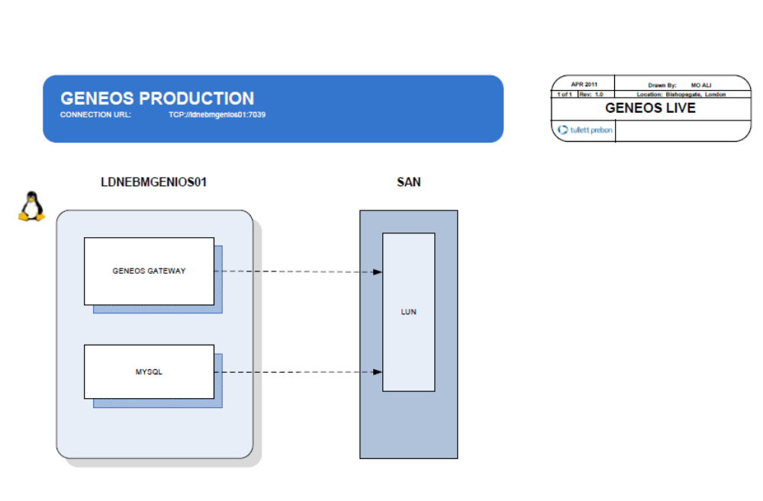
1
2
3

  - Architectural Components

KEY | DESCRIPTION | OPERATING SYSTEM SUPPORT
1 | LDNEBMGENIOS01  This is the Geneos Gateway host name  (Port 7039) The geneos monitoring gateway communicates with Netprobes | PRODUCTION SUPPORT (LINUX)
2 | MySql 5.0 is installed locally as a database store for monitoring events | PRODUCTION SUPPORT (LINUX)
3 | HP EVA Cluster San  SAN Mounted LUNS  /opt/app | SERVER SUPPOTR LONDON

  - Installed Third Party Software and Versions

The following software has been installed in the production Geneos environment.

Host | Installed Software | Purpose | Version | Binary Location
LDNEBMGENIOS01 | Java JDK | Provide the runtime java environment, used by Replay Server and Subscription Watcher | 1.6_21 64 BIT | \\ldnr200\ebRepository\Middleware\Installers\EMS Installation Files\jdk-6u21-windows-x64.exe
LDNEBMGENIOS01 | Geneos Gateway | Collects monitoring information from all installed netprobes. Generates email and dashboard alerts | GA2010.4-110203 | \\ldnr200\ebRepository\Geneos\JAN11\gateway2.linux.GA2010.4-110203.tar.gz
LDNEBMGENIOS01 | MySql 5.0 | Monitoring events are stored to this database. | 5.0.67

These versions are correct as of April 2011.

Geneos Operational Support

  - Introduction
Surveillance of the Geneos environment is done manually using start of day activities and eyes-on-glass during business working hours.

24/7 support of the Geneos environment is as follows:

Days | Hours (GMT) | Support Team | Phone
Saturday & Holiday Weekends | On Call | On Call | Production Support On Call Only
Sunday | On Call | On Call | Production Support On Call Only
Mon – Fri | On Call | On Call | Production Support On Call Only
Mon – Fri | 07:00 – 19:00 | UK Production Support
Mon – Fri | On Call | On Call | Production Support On Call Only

  - Support Tools

A number of tools are required to be installed to support the Geneos Environment. They are as follows:

Desktop Firewall authentication

You will need to authenticate against the following firewall in order to gain access to the Geneos Production Environment and use the support tools:

http://192.168.51.1:900

Geneos Active Console

To launch the Geneos Active Console, follow these steps:
- Mount the following drive: \\ldnr200\ebRepository\Middleware\Monitoring\geneos
- Unzip the file ActiveConsole.GA2010.4-101222.zip to your local computer, say C:\ActiveConsol
- Copy the file \\ldnr200\ebRepository\Middleware\Monitoring\geneos\tpbus.aws to your local computer, say C:\ActiveConsole
- Run the application C:\ActiveConsole\ActiveConsole.exe
- You will be presented with the following screen

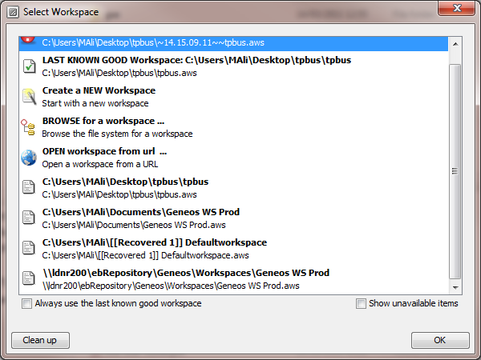

- Select BROWSE for a workspace
- Select the tpbus.aws file from C:\ActiveConsole
- You will now be presented with this screen:

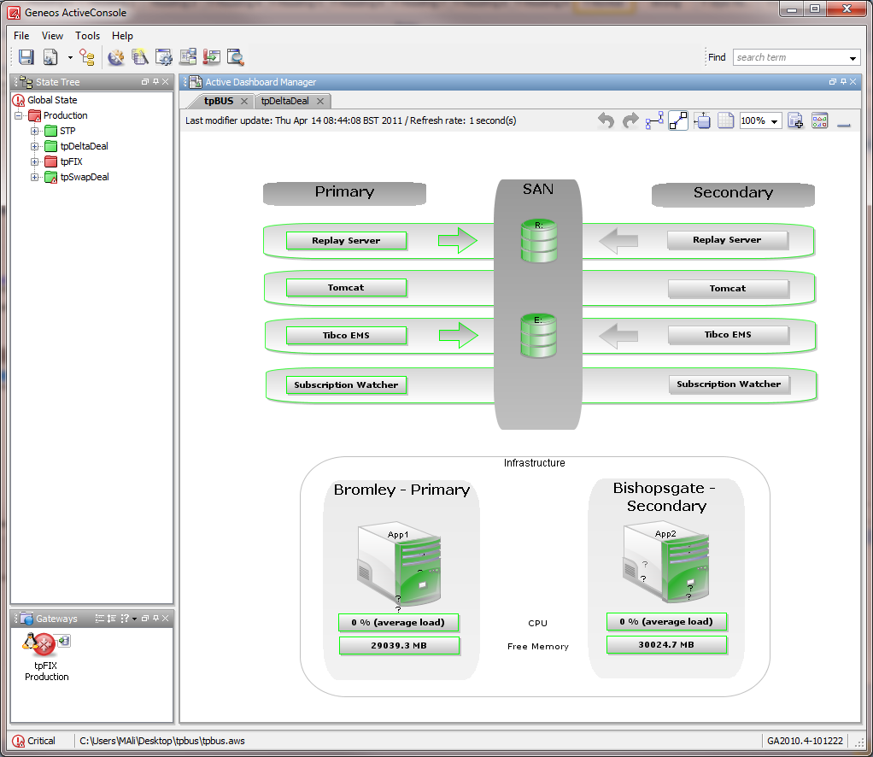

- This Geneos dashboard provides a traffic light overview of all components of the tpBus

  - Start of Day Activities
The following start of day activities must be followed for the Geneos environment:

- Check the Geneos Active Console has no errors (all green)
- Log into the server ldnebmgenios01 and check the processes are running as follows:

ps -eaf | grep mysql
ebuser 1334 13316 0 16:06 pts/1 00:00:00 grep mysql
root 4711 1 0 Apr08 ? 00:00:00 /bin/sh /usr/bin/mysqld_safe --mysqld=mysqld --user=mysql --pid-file=/var/lib/mysql/mysqld.pid --socket=/var/lib/mysql/mysql.sock --datadir=/var/lib/mysql
mysql 4752 4711 0 Apr08 ? 00:04:28 /usr/sbin/mysqld --basedir=/usr --datadir=/var/lib/mysql --user=mysql --pid-file=/var/lib/mysql/mysqld.pid --skip-external-locking --port=3306 --socket=/var/lib/mysql/mysql.sock

ps -eaf | grep itrs
ebuser 1682 13316 0 16:07 pts/1 00:00:00 grep itrs
netagent 3454 1 0 Apr08 ? 00:22:11 /usr/local/itrs/gateway.tpfix/gateway2.linux Production.Fri8Apr2011.23:14:13
netagent 3466 1 0 Apr08 ? 00:18:47 /usr/local/itrs/netprobe/netprobe.linux_64

If any issues are detected, please email any issues to:

tbglobalops@tullettprebon.com

  - End of Day Activities
There are no end of day activities for the Geneos production environment.

  - Automated Monitoring
There is no automated monitoring of Geneos

  - Automatic Failover
There is no automated monitoring of Geneos
  - Manual Failover
Manual failover should only be actioned by either Server Support or Geneos 3rd line support.
  - Failback
Manual failover should only be actioned by either Server Support or Geneos 3rd line support.

  - Backup
As of April 2011, the following backup strategy is employed:

Backup tool used: Asigra
Backup jobs include
- LDNEBMGENIOS01 - /usr/local/itrs

Backups are initiated at 10pm Mon through to Friday

  - Restore

In the event that any of the LUN mount points fail, escalate immediately to tbglobalops@tullettprebon.com

  - Archiving

TBD

  - Incident Management

Step | Description | Responsibility
1 | Issues detected by any user should be escalated as a first step to tbglobalops@tullettprebon.com  Issues can be raised by any internal user – whether application owners or Unix Admins | Whoever detects an issue with the Geneos environment
2 | Global Operations will subsequently own and manage the logging, reporting and resolution of the issue | Global OPS
3 | Please refer to the Key Contacts to determine escalation points | Global OPS

Geneos Licence Updates

The Geneos licences are required to be updated every 6 months. The process of updating the licence is as follows:

Step | Instruction
1 | Email to: helpdesk@itrsgroup.com  Body of email to contain:  Please can you supply licences for the following Geneos Gateway 2 servers at Tullett Prebon  1) hostname: ldnebmgenios01  hostid: 0xffffffffa8c0b225  2) hostname: ldnebmgeniosuat01  hostid: 0xffffffffa8c0da26  3) hostname: ldngeneosdev01  hostid: 0x7f0200
2 | The response from ITRS will contain licence codes such as:  D.2A.15.FA.AA.F5.8A.F3.39  S.90.A0.01.11.57.9D  The above licence is valid until October 2011
3 | SSH to the geneos gateway server
4 | Go to the correct licensing folder:  UAT: /usr/local/itrs/gateway.irs/licensing/gateway2.lic.tmp (A single shared license is now in use, See below)  DEV: /usr/local/itrs/gateway.dev/licensing/gateway2.lic.tmp (A single shared license is now in use, See below)  PROD: /usr/local/itrs/gateway.tpfix/licensing (A single shared license is now in use, See below)  Enterprise Servers: /usr/local/itrs/gateway/active_1/licensing  : /usr/local/itrs/gateway/active_2/licensing  Where there’s is a single common shared license daemon the license file is replaced in a single location only. This applies to PROD, DEV and UAT  DEV:ldngeneosdev01:/usr/local/geneos/licd/geneos.lic (no license to install on UAT)  PROD: ldngeneosgw02:/usr/local/geneos/licd/geneos.lic (no license to install on ldngeneosgw01)
5 | Where the shared license daemon is in use, stop the Geneos gateway license daemon  service license_daemon stop  Then stop the geneos gateway processs (see below)  Shut down the gateway application (make sure you are in the correct ITRS folder for the environment you have SSH’d to)  service itrs_gateway stop  Enterprise servers: service itrs_gateway_citrix.prod.sh stop OR  : ./usr/local/itrs/gateway/admin_scripts/gateway.sh 1 stop AND  : ./usr/local/itrs/gateway/admin_scripts/gateway.sh 2 stop
6 | Where a single shared common license daemon is used, rename the old license file geneos.lic to geneos.lic_ YYYYMMDD for example other wise, rename the old licence file gateway2.lic.tmp to gateway2.lic.tmp_YYYYMMDD.
7 | For a shared license daemon create a new file called geneos.lic with the contents of the new license supplied by ITRS. This file should be owned by the netagent user and group. Otherwirse, create a new file called gateway2.lic.tmp with the contents of the two lines described in Step 2 above  This file should be owned by the netagent user and group  NB. There is a gateway2.lic.tmp file in both active_1/licensing and active_2/licensing. Editing one file automatically edits the other file.
8 | Where the shared license daemon is in use, restart the Geneos gateway license daemon  service license_daemon start  Then procees to restart the geneos gateway (see below)  Otherwise (for non shared license daemon configurations)  Restart the geneos gateway  DEV – service itrs_gateway.dev start  UAT - service itrs_gateway start  Enterprise Servers: service itrs_gateway_citrix.prod.sh start OR  : ./usr/local/itrs/gateway/admin_scripts/gateway.sh 1 start AND  : ./usr/local/itrs/gateway/admin_scripts/gateway.sh 2 start
9 | Check the new status of the installed license using the below URL (appropriately modified for the Geneos environment you want to check)  http://[hostname]:7042/licensing/  e.g For production it’s http://ldngeneosgw02:7042/licensing/

Geneos Primary Site Failure

In the event of a failure of the Primary Site System, the following steps need to be taken in order to restore operation:

Task | Description | Responsibility
Failure verification | Confirm that the primary application is unavailable | Production Support
Notification email (support) | Communicate an issue to tbglobalops@tullettprebon.com | First person to detect issues
Notification email (clients) | Communicate to all application owners listed here of primary site failure: | Global OPS
Perform Failover | Do the following steps:  - Obtain a copy of the latest gateway.setup.xml from production (use the Asigra backups from last night if the production server is not available)  - Copy the gateway.setup.xml to the server ldnebmgeniosuat01 (DR gateway)  - The location to copy to is /usr/local/itrs/tpfix_dr.gateway  - You will need to overwrite the existing gateway.setup.xml file  - The DR gateway should be restarted  - The DNS ldngeneosprod to be failed over to the IP address of ldnebmgeniosuat01  - Confirm the Production Active consoles are operational | Geneos 3rd line support
Notification (support) | Communicate to tbglobalops@tullettprebon.com that the application is either operating in standby mode or has further errors | Geneos 3rd line support
Notification (clients) | Communicate to all clients when the application is available | Global OPS

Geneos SAN failure

TBD

Change Management

All changes must follow TULLETT PREBON change management procedures.

Change Window

All changes must be performed after market close (17:30), and depending on the nature of the change. This should be discussed during change planning to select the appropriate day and time based on risk.

Weekly CAB Meeting
Operations Manager and CAB Members attend weekly meeting. This is held every Thursday at 09:00 AM. EST (14:00 GMT)
UK: 0844 561 0081
USA: +1 718 354 1169
Singapore: +65 6415 5062
Chairperson passcode: 13642664 then #
Participant passcode: 30766299 then #

